Instructions for self-loading drivers for Linde H35/H45/H70/H80 forklift trucks

Forklift trucks must always be visually inspected before being put into service and the last entry in the logbook must be checked. In the event of any defect or log entry affecting safe or proper use or damage, the forklift truck must not be used and the PIN must not be activated. Any problems should be reported immediately to the +36-88-620-196 Transport Dispatcher.
In such cases, the forklift truck may only be used in accordance with the instructions provided afterwards.
The forklift trucks can only be used with the PIN code received at the time of entry or with another device that can be used to start the truck. In the event of an incorrect PIN (wrong PIN), the two indicator lights on the PIN pad will light up red for a short time. The correct PIN can then be re-entered. The active code is indicated by the continuous green light of the two indicators.
If a previous PIN code was accidentally left active when the forklift trucks were put into service (two green lights continuously), it must be deactivated before entering your own PIN code, using the PIN pad 🞕.
The forklift can only be started when the parking brake is active (by turning the parking brake lever forwards). The parking brake can be released by turning the rotary switch backwards after pressing the locking button.
It is mandatory to keep lifting equipment logs placed in forklifts. Before putting into use, it is mandatory to check the previous entry, then enter the current date/time and the starting time. After use, it is mandatory to enter the closing operating hours, a short text regarding the forklift's condition (usually the entry "Operable" is sufficient, but in the case of a technical fault/observation, a short description of this), and the signature of the driver (forklift user).
In the event of a technical fault, damage, accident or any other anomaly detected during use, it must be reported immediately to the +36-88-620-196 Transport Dispatcher.
After the loading is completed, the active PIN must be deactivated by pressing the button on the PIN pad marked with the symbol 🞕.
A description of the forklift controls and the display/reaction unit is given in Annex 1.

Training material for operators of Linde H20/25D, H30/35D, H45D, H70/80D forklift trucks

General handling and security
- Basic forklift truck controls (using illustrations from machine manuals)
- Significant differences from other types (pedal shift system, hydrostatic drive train, PIN-code operator identification system, how they work and how they are used)
- Requirements for keeping a logbook for lifting machinery
- Content of the inspection carried out during the shift, highlighting local specificities (elements requiring special attention due to the terrain: condition of wheel bolts, tyres, lifting chains and forks)
- How to report technical faults or possible accidents or incidents
- The use of adapters to match the forklift's load capacity

Type specific handling leaflets
- Manual regeneration of the DPF (Diesel Particulate Filter) of the H70/80D models (technique; hazards)
- AdBlue system

Loading tasks at the plant, major hazards, safe loading
- Hazards of loading at the output lines of packaging plants (narrow space, pedestrian traffic, limited visibility)
- Accident-prone situations during BB depot operations, especially during the demolition of 3-level depots (moving goods above eye level; risk of the bottom of BB bags getting caught in the event of improper lifting; risks of swinging loads during BB loading; avoiding the risks of moving with a lifted load)
- Dangers of loading onto transport vehicles (keeping persons out of reach; limited visibility due to the dimensions of BB adapters, lifting columns)
- Risks related to soil conditions in some storage areas (possible potholes in graveled areas, occasional heavy dusting or mud accumulation; possible increased vehicle and pedestrian movements)

Linde H35D, H45D, H70D, H75D controls
1. Turn signal indicator
2. Steering adjusting screw
3. Turn signal/wiper switch
4. Steering wheel
5. Parking brake rotary knob
6. Launch button
7. Raise/lower joystick lever
8. Page navigation joystick arm
9. PIN-pad (under the opening elbow rest)
10. Reverse pedal
11. Brake pedal
12. Forward pedal
13. Horn push button
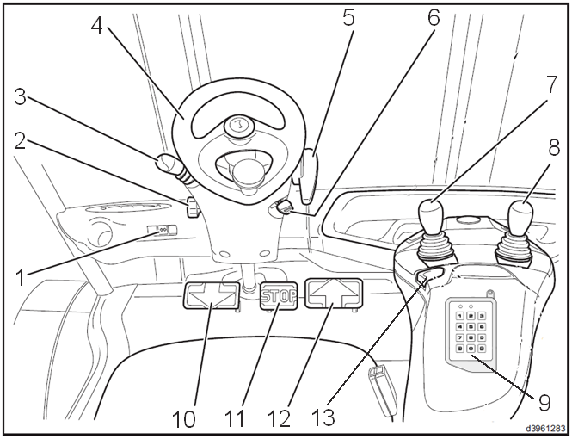
1. Display unit
2. Hydraulic oil temperature high
3. Charging feedback
4. Engine oil pressure/level low
5. Electrical control fault
6. Coolant temperature high
7. NOT ACTIVE
8. NOT ACTIVE
9. Particle filter clogged
10. Catalytic converter malfunction
11. Water in the fuel
12. NOT ACTIVE
13. Hydraulic filter clogged
14. Light intensity sensor
15. Time/date display
16. Operating hours display
17. Function display
18. Drive mode display
19. Parking brake active display
20. Seat belt warning
21. Engine cannot be started warning
22. Approval button
23. Menu "LE” (down) button
24. Menu "FEL” (up) button
25. Menu “VISSZA" (back) button
26. Maintenance interval exceeded
27. Particle filter regeneration active display
28. NOT ACTIVE
29. NOT ACTIVE
30. Crawl mode active display
31. Operational error menu
32. Settings menu
33. Favourites menu
34. Status display menu
35. Fuel level indicator
36. Air filter clogged indicator
37. Low coolant level indicator
38. Ignition/malfunction indication
39. NOT ACTIVE
40. NOT ACTIVE
41. NOT ACTIVE

Linde H35D, H45D, H70D, H75D display unit
